EASTERN GOLDFILEDS COLLEGE
YEAR 12 AMTHEMATICS METHODS
INVESTIGATION 2
LOGARITHMIC FUNCTIONS PART A

TRANSFORMATIONS

Will logarithmic functions undergo transformations in the same way as other functions.
For example, we know that 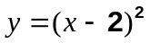 will be the same shape as the graph of 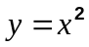,
but translated two units to the right.

Complete the following investigation to find the effect of transformations on logarithmic functions.

The in-class assessment will require you to determine the equation for each of a number of logarithmic functions for which the graph is given.
You may keep Part A with you while you complete Part B in class.

PART A:

I) On graph paper, sketch the graph of the function 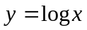 for 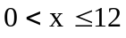.
Use a scale of 2 cm = 1 unit.

On the same set of axes, investigate the graphs of 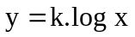 for various integer values of k. Consider both positive and negative values of k and also the effect of x being negative.
Write a short summary showing any information you have found that would help you identify graphs of the form

In a similar manner, investigate the following functions for various integral values of k.

II) 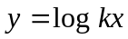

III) 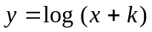

IV) 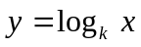

Use your investigations of the above functions to answer the following questions.
The following graphs are transformations of the graph 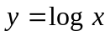.
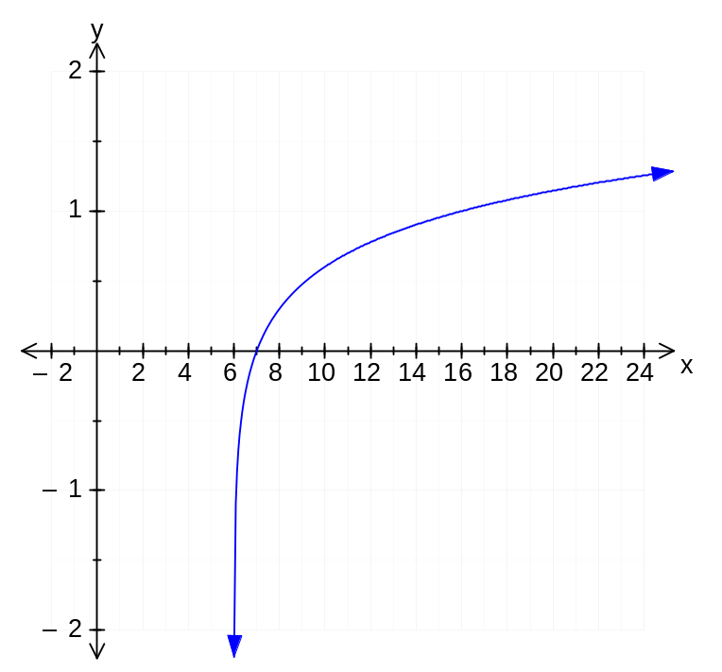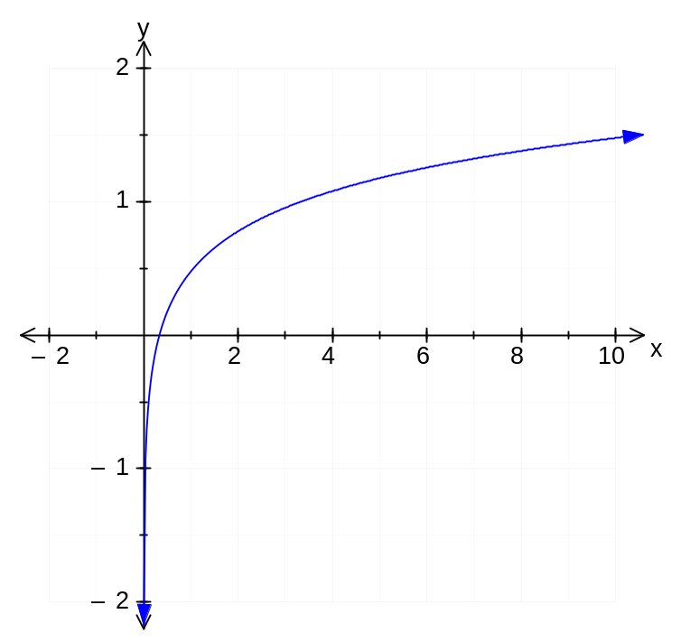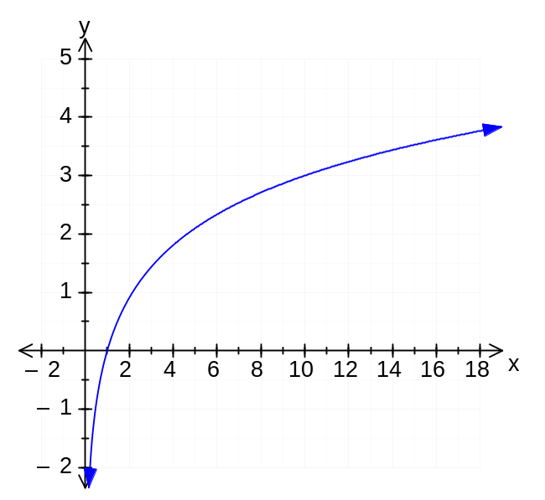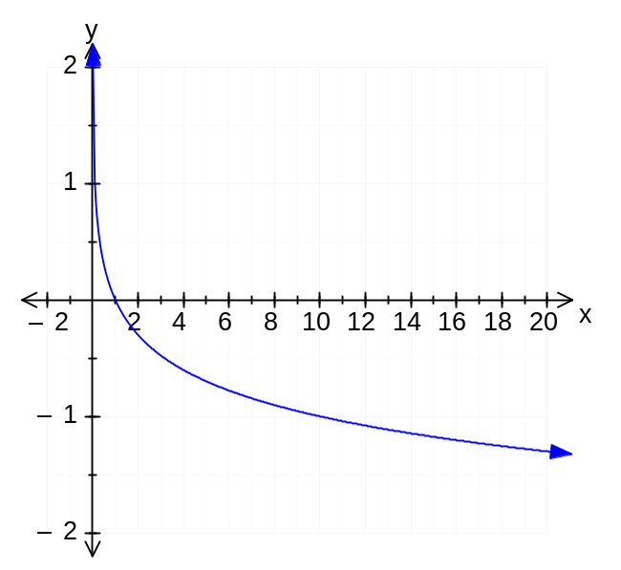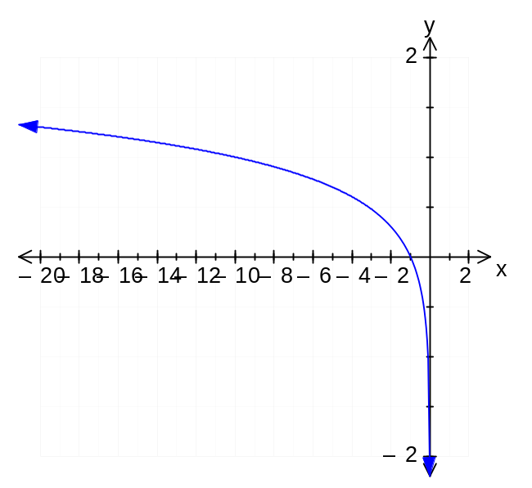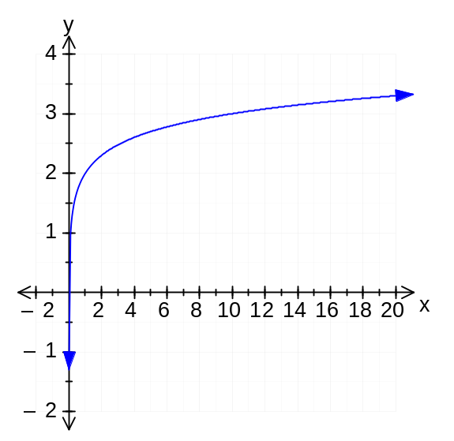State the equation of each function.
The function graphed in each of the following graphs is of the form 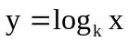.
Examine the graph and then determine the equation.
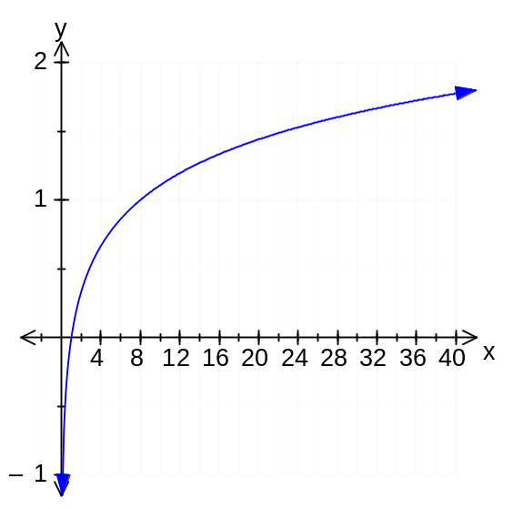
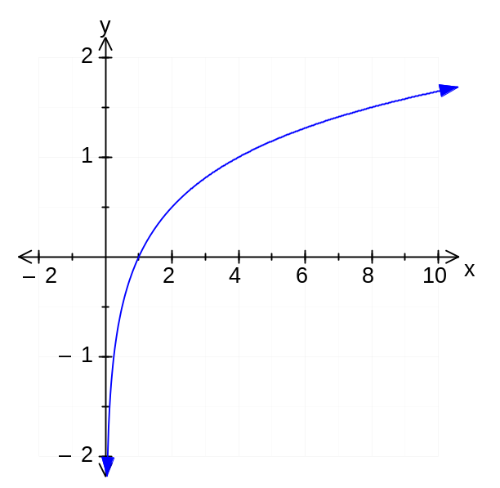Determine the equation of the function graphed in each of the following, given that the graph is a transformation of the graph of 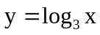.
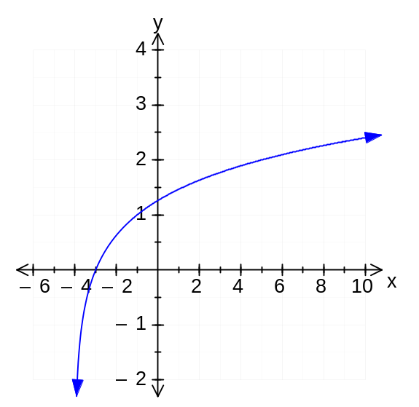
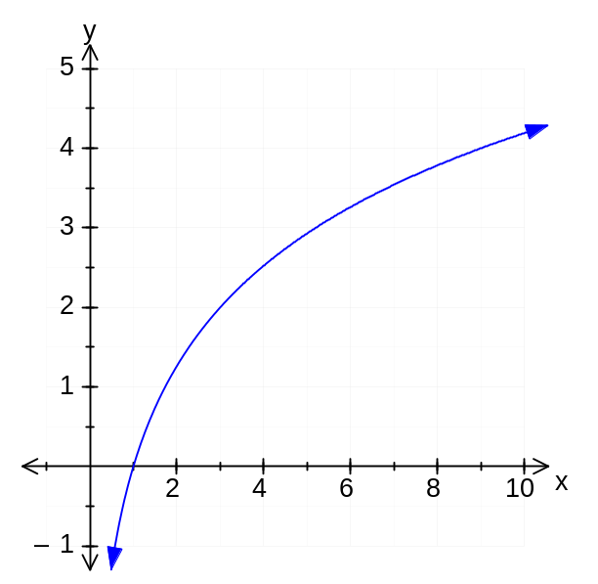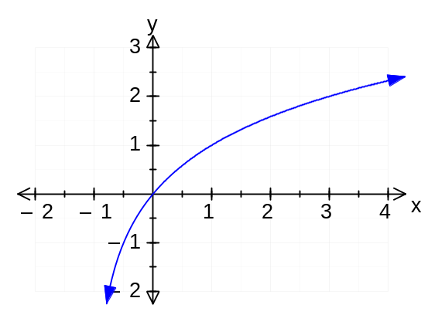The following graph is a function of the form 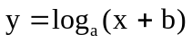. Determine the values of a and b.

